PROJECT DEMONSTRATION PHASE
AI BLOGNEST API
Project Demonstration Report
Project Name | AI BlogNest API
Team ID | SWTID-2026-7288
Date | 24 September 2026

1. Demonstration Objective
The AI BlogNest API demonstration is organized around the actual backend source structure rather than a generic feature list. The objective is to show how a protected Express API connects authentication, role checks, blog operations, comments, MongoDB persistence and Google Gemini-based content assistance.
- Demonstrate the request path from an API client into middleware, controllers, services and models.
- Show how JWT verification establishes the authenticated user before protected operations are executed.
- Demonstrate role-aware blog creation, editing and deletion behavior.
- Show AI endpoints for ideation, generation, improvement, summarization, chat and FAQ creation.
- Show content lifecycle handling including draft, pending, published, rejected and scheduled states.
- Demonstrate engagement and analytics information exposed by the blog controller.

2. Source Structure Used for the Demonstration
The supplied source files reveal a modular backend organized around middleware, routes, controllers, services, models and configuration. The folder structure visible in the supplied project screenshot is used as the primary visual reference for this section.
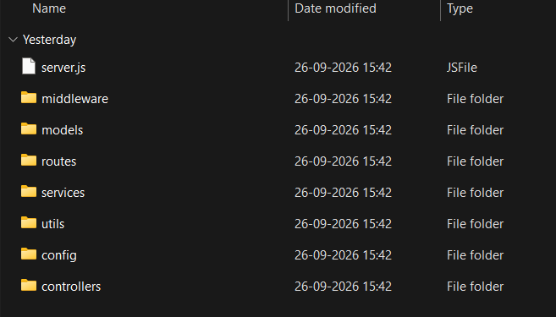
Figure 1. Supplied AI BlogNest backend source structure used for the demonstration.
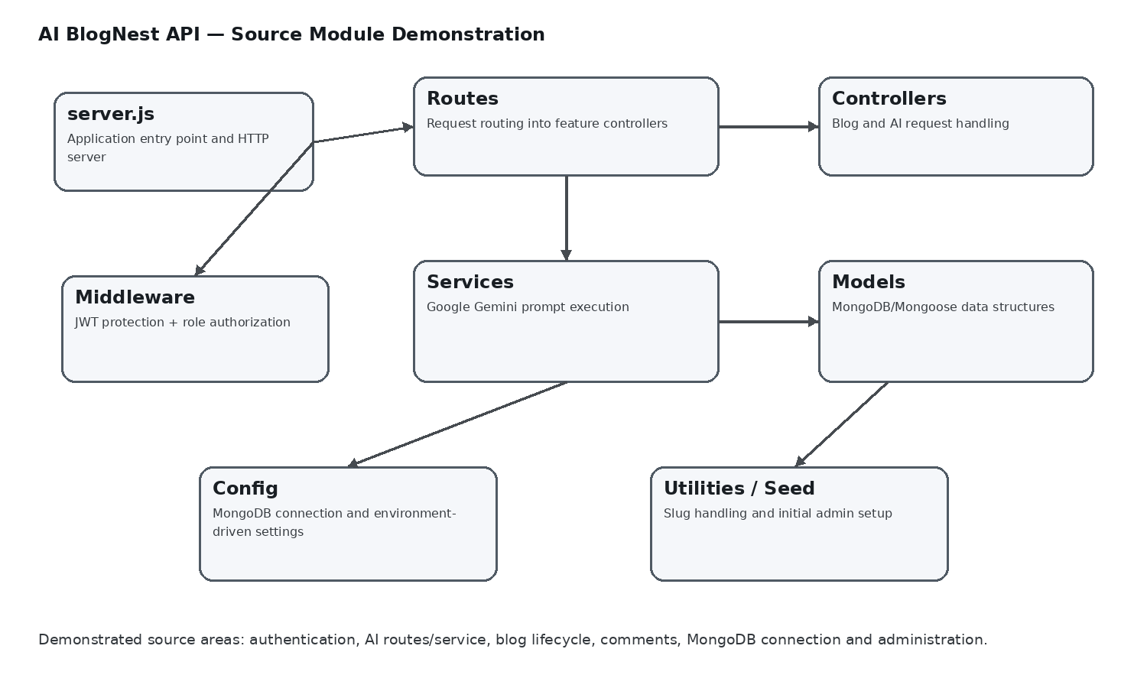
Figure 2. Source-module relationship used to explain the demonstration.

3. Database Connection and Runtime Foundation
The database layer uses Mongoose. The connection function reads MONGO_URI from the environment and opens the MongoDB connection before the application uses database-backed features. This keeps connection details outside the source code and allows the same backend code to run with different environment configurations.
The project also includes an initialization script that connects to the database, checks for an administrator account, and creates the account when it does not already exist. The demonstration should therefore show database availability separately from normal request processing.
- MongoDB connection is established through a reusable connectDB function.
- The administrator initialization script avoids creating a duplicate account when the configured admin email already exists.
- Database-backed resources used by the supplied code include users, posts and comments.

4. Authentication Demonstration
Authentication is implemented as reusable middleware. A protected request must provide a Bearer token in the Authorization header. The middleware verifies the JWT using the configured secret, retrieves the corresponding user and checks that the account is active.
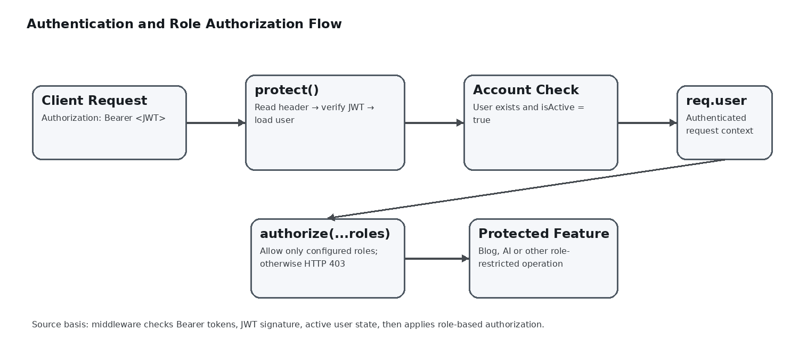
Figure 3. JWT authentication and role authorization flow derived from the supplied middleware.
- Missing or malformed Bearer authentication produces HTTP 401.
- An invalid or expired JWT produces HTTP 401.
- A missing or inactive user account is rejected before the controller runs.
- A valid user is attached to req.user for downstream authorization and ownership checks.
This middleware is the common security gate for the AI router, while the blog controller additionally performs ownership and role checks for content changes.

4.1 Runtime Readiness Demonstration
Before feature testing begins, the backend should be shown as operational. The database connection is encapsulated in a reusable connectDB function that reads the MongoDB connection value from the environment. A separate initialization utility checks whether the administrator account exists and creates it only when needed. This keeps startup preparation distinct from request-handling logic and gives the demonstration a clear starting point.

5. Role-Based Authorization Demonstration
The authorize helper receives a list of permitted roles and compares it with req.user.role. A request whose role is not included is stopped with HTTP 403. This provides a reusable role gate that can be attached to routes according to the feature being protected.
- Authentication answers whether the request has a valid user identity.
- Authorization answers whether that authenticated role is permitted to perform the requested operation.
- The blog controller also applies ownership rules so that content modification is not based on role alone.
For demonstration, use at least one valid token and one token associated with a role that is not permitted for a selected protected route. The expected difference is HTTP 401 for failed authentication versus HTTP 403 for failed authorization.

5.1 Security Response Demonstration
The security layer produces different outcomes for different access problems. A request without a Bearer token is treated as unauthenticated, while an invalid or expired JWT is rejected during verification. A valid token with a role that is not allowed for a protected operation reaches the authorization check and receives HTTP 403. Demonstrating these cases helps distinguish identity verification from permission enforcement.

6. Blog Content Management Demonstration
The supplied blog controller implements a complete content lifecycle. A new post receives a generated slug, default category handling, tags and media, an author reference and a publication state. Authors are constrained to draft or pending when they attempt to create a post with another state.
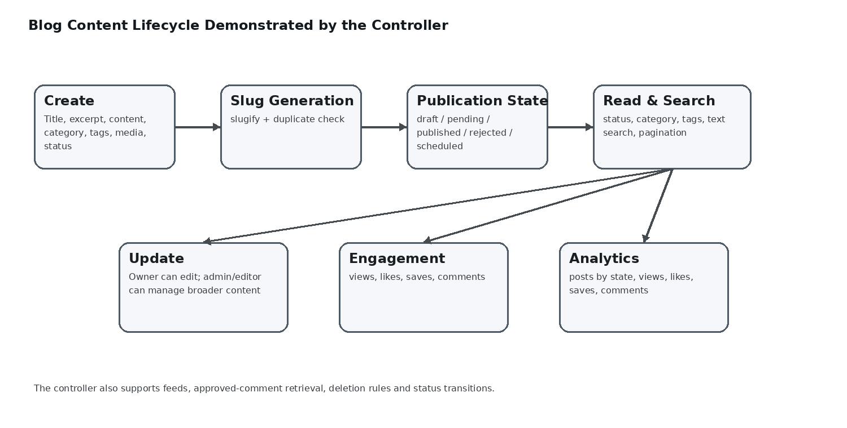
Figure 4. AI BlogNest blog lifecycle represented from the supplied controller logic.
- Create: title, excerpt, content, cover image, category, tags, media, status and optional scheduling data.
- Read: published-state filtering, category and tag filters, text search and pagination.
- Detail: author information, view increment and approved comments.
- Update: owner-based editing plus broader admin/editor management.
- Delete: owner or administrator permission.
- Status transition: draft, pending, published, rejected and scheduled.
- Engagement: like and save toggling for the authenticated user.
- Analytics: totals for posts, publication states, views, likes, saves and comments.

7. Slug and Content Organization Demonstration
The controller uses slugify to convert a title into a lowercase, strict URL-friendly slug. Before returning the slug, it checks for an existing post with the same value. If a collision exists, a timestamp suffix is appended. This prevents two posts from being assigned the same slug.
- Title: human-readable blog title.
- Slug: normalized identifier suitable for URLs.
- Category and tags: structured discovery fields.
- Search: title, content and tag matching with case-insensitive regular expressions.
- Pagination: page and limit parameters control the returned result set.

7.1 Publication Status and Scheduling
The post workflow includes draft, pending, published, rejected and scheduled states. The create operation applies a rule for authors so that attempts to start with an unrestricted publication state are normalized to draft. When administrators or editors schedule a post, scheduling information is required. These rules make the demonstration more meaningful than a basic create-and-read sequence because the backend actively controls the content lifecycle.

8. Comment Moderation Demonstration
Comments are stored with references to both the post and the user. The supplied schema trims comment text, limits it to 1,000 characters and assigns a moderation status. New comments default to pending, allowing the platform to separate submission from public display.
- Comment text is required and trimmed.
- Maximum comment length is 1,000 characters.
- Supported moderation states in the supplied schema are pending, approved, spam and rejected.
- When a post is retrieved, only approved comments are returned by the blog controller.
- New comments are acknowledged as submitted for moderation rather than immediately treated as approved.

8.1 Comment Data and Moderation States
The comment model links a comment to both a post and its authoring user and records timestamps automatically. Comment text is required, trimmed and limited to 1,000 characters. Its moderation lifecycle includes pending, approved, spam and rejected states. Because the blog controller retrieves only approved comments for public post details, the system demonstrates a deliberate separation between submitting a comment and publishing it.

9. AI Route Demonstration
The AI router is protected by the authentication middleware and exposes multiple AI-assisted capabilities. This is broader than simple blog generation: the same service layer supports ideation, content improvement, summarization, conversational assistance and FAQ generation.
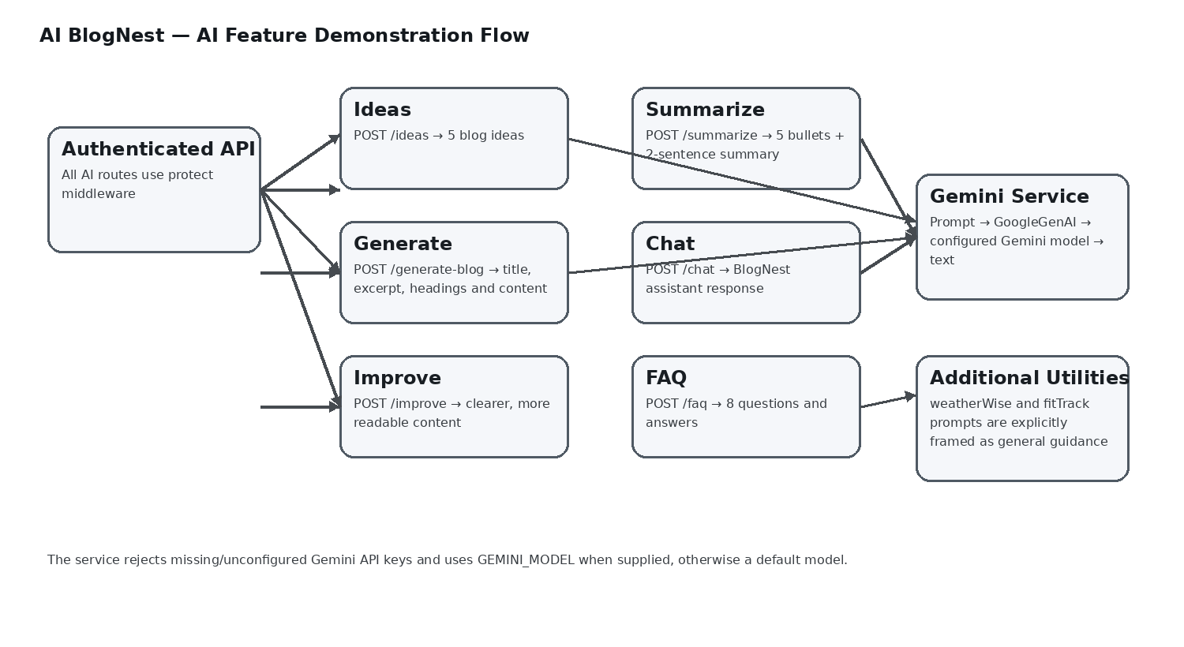
Figure 5. AI capability flow derived from the supplied AI router and Gemini service.
- POST /ideas — produces five simple blog ideas for a topic.
- POST /generate-blog — creates a complete blog with title, excerpt, headings and useful content using a requested tone.
- POST /improve — rewrites supplied blog content for clarity, grammar and readability.
- POST /summarize — returns five bullet points and a two-sentence summary.
- POST /chat — provides a concise AI BlogNest assistant response.
- POST /faq — generates eight frequently asked questions with answers.
- POST /weatherwise and /fittrack — provide explicitly general guidance with limitations stated in their prompts.

9.1 AI Prompt Design Demonstration
The AI service uses separate prompt templates for separate tasks. Idea generation asks for five simple ideas; blog generation requests a complete article with a title, short excerpt, headings and useful content in a selected tone; improvement focuses on clarity, grammar and readability; summarization requests five bullet points and a two-sentence summary; and FAQ generation asks for eight question-and-answer pairs. This task-specific prompting is a key project feature because it turns one Gemini integration into multiple useful authoring tools.
A practical demonstration can reuse one topic across the AI tools. The presenter can generate ideas first, create a draft from the topic, improve the draft, and then produce a compact summary. This shows how AI features support different stages of the same content workflow.

10. Google Gemini Service Demonstration
The AI service initializes GoogleGenAI with GEMINI_API_KEY and sends prompts to the configured Gemini model. If the key is missing or still contains the placeholder value, the service throws a configuration error instead of silently making an AI request.
- GEMINI_API_KEY controls access to the AI provider.
- GEMINI_MODEL can select the model; the supplied service falls back to gemini-2.5-flash when no model is configured.
- Each exported service function builds a focused prompt for one AI capability.
- The service returns generated text or a fallback message when no response text is produced.

11.5 Verification and Test Coverage
The development records identify registration, login, authentication, role-based access control, blog CRUD, categories, comments, AI generation, AI summarization, keyword search, semantic search and vector search as major verification areas. The documented phase result is 25 passed and 0 failed. In the demonstration report, this result is best used as supporting evidence after the live functional walkthrough.

11.4 Search Strategy Demonstration
AI BlogNest separates direct term discovery from semantic discovery. The project documentation includes MongoDB Atlas Search for keyword-based matching and MongoDB Atlas Vector Search for embedding-based retrieval. This distinction lets the demonstration show why a reader might use a conventional keyword query in one situation and a meaning-oriented query in another.
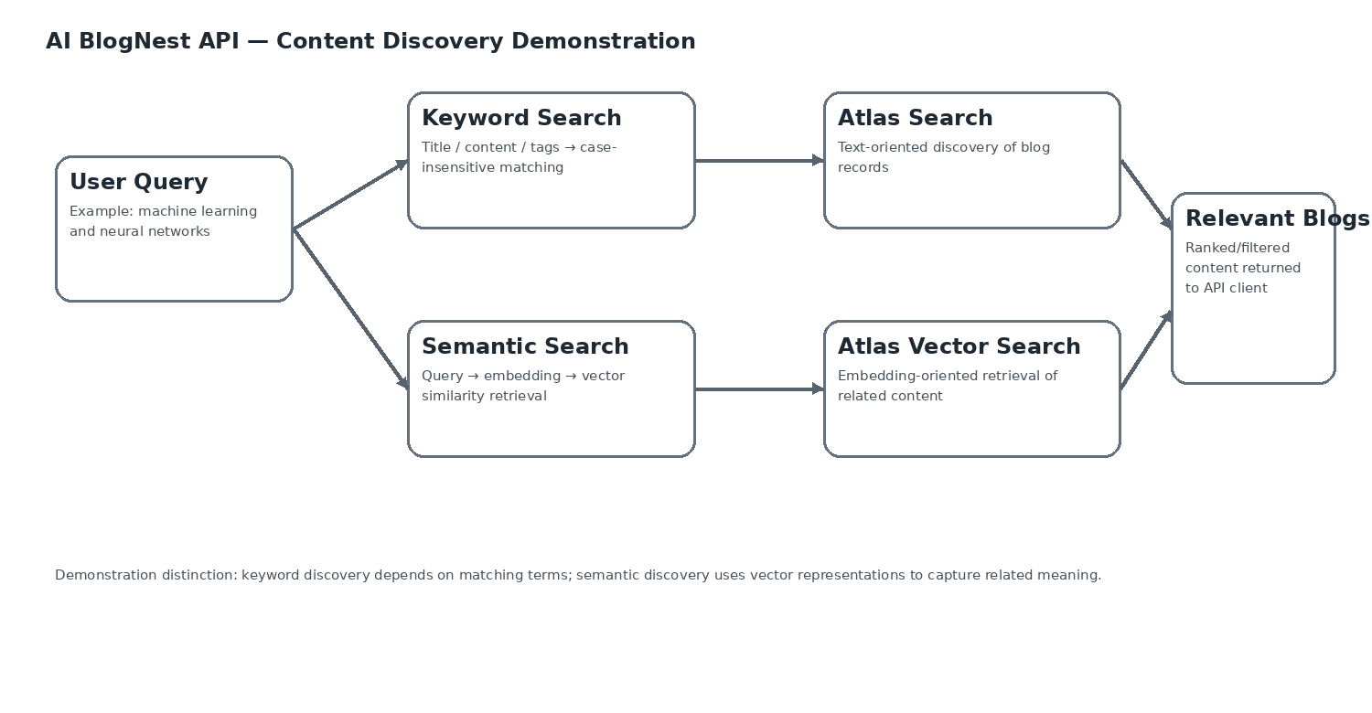
Figure 6. AI BlogNest content-discovery paths for keyword and semantic search.
A useful live scenario is to search for a term that is visibly present in a post and then search for a concept expressed with different wording. The first request illustrates direct text matching; the second illustrates the purpose of semantic retrieval through vector representations.

11.3 Content Lifecycle and Engagement Demonstration
The blog controller combines editorial state with reader interaction. A post can move between draft, pending, published, rejected and scheduled states, while the same record can accumulate views, likes and saves. The analytics operation summarizes these values along with comment counts and totals by publication state.
For a strong project demonstration, follow one article from creation through publication and reader interaction: create the post, revise metadata, publish it with the appropriate permission, open the detail endpoint to increment views, toggle a like or save, and then inspect the analytics response.

11.2 Role and Ownership Demonstration Matrix
The four project roles create distinct access paths: Admin, Editor, Author and Reader. Role middleware provides reusable permission checks, while the blog controller also compares the stored author ID with the authenticated user ID for ownership-sensitive updates and deletion. This means the project demonstrates both role-based permission and record-level ownership.
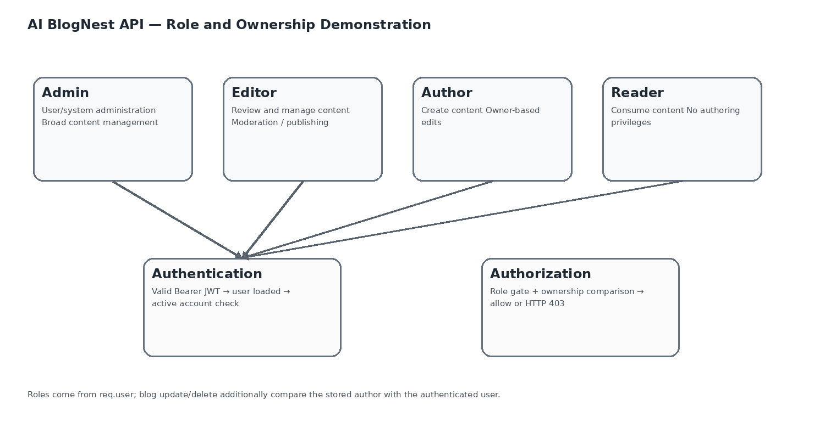
Figure 7. AI BlogNest role and ownership model used in access-control demonstrations.

11.1 End-to-End API Request Lifecycle
Protected requests can be explained as a sequence of stages: an API client sends an HTTP request; middleware validates identity and, where configured, role access; the route selects the feature; the controller applies business rules; a service or model performs the AI or database operation; and the API returns a JSON response. This lifecycle shows how the source folders work together during a real request instead of appearing as isolated files.
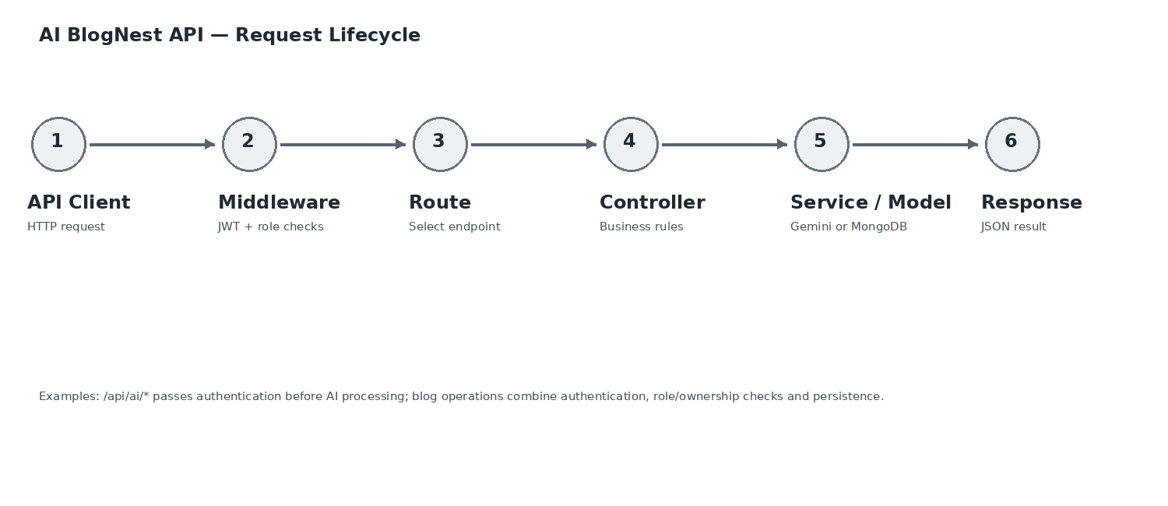
Figure 8. End-to-end request lifecycle for AI BlogNest API operations.

11. Demonstration Scenarios

Scenario A — Protected AI request
Authenticate a user, obtain a JWT, then call an AI route with the Bearer token. The request should reach the AI controller only after the authentication middleware accepts the token.

Scenario B — Blog creation with publication rules
Create a post as an author using a draft or pending state. Attempting a different initial state is normalized to draft by the supplied controller logic.

Scenario C — Ownership-aware editing
Create a post, then attempt to update it from another non-admin/non-editor user. The controller compares the stored author ID with the authenticated user ID before allowing the change.

Scenario D — Comment moderation
Submit a comment and inspect its initial pending state. Retrieve the post and verify that only comments marked approved are included in the response.

Scenario E — AI content pipeline
Use the same topic across /ideas, /generate-blog and /summarize to demonstrate the progression from topic exploration to content creation and condensed output.

12. Demonstration Evidence Matrix
Demonstration Area | Source Evidence | Expected Demonstration Focus
Authentication | auth middleware | JWT verification, active-user check and HTTP 401 responses
Authorization | authorize helper + blog controller | Role restrictions and ownership protection
AI routing | ai routes + AI service | Protected AI endpoints and prompt-driven capabilities
Blog management | blog controller | CRUD, slugging, lifecycle states and engagement
Comments | comment model + blog controller | Pending moderation and approved-only display
Database | MongoDB connection | Mongoose connection through MONGO_URI
Administration | seed script + analytics controller | Admin initialization and content metrics

13. Demonstration Outcome
The demonstration covers the project capabilities visible in the supplied implementation: modular Express routing, protected AI endpoints, JWT authentication, role and ownership checks, blog lifecycle management, slug creation, tags and categories, comment moderation, reader engagement, analytics, MongoDB persistence and Google Gemini-assisted authoring. The project is therefore demonstrated as an integrated backend rather than as a collection of unrelated API examples.
The source-based sections are limited to behavior supported by the provided code and project documentation. The reported verification result for the demonstration/development phase is 25 passed and 0 failed; live screenshots and actual response payloads can be captured during execution when required by the evaluation format.

14. Conclusion
AI BlogNest API demonstrates a structured backend approach in which content management and AI assistance are implemented as coordinated services rather than isolated endpoints. The supplied code shows clear boundaries between middleware, routes, controllers, services, models and configuration. For the project demonstration, this architecture can be presented through a sequence of authenticated requests that move from user verification to content operations and finally to AI-assisted workflows.

